
Object Oriented Programming
Course Project Report
on
VIT MULTI-DEPARTMENT ACADEMIC CALENDAR SYSTEM
Submitted by
Student Name | Roll Number
Nupur Talathi | 2090629
Anushka Wankhede | 2090652
Pruthviraj Tagare | 2090628

Under the Guidance of
Mrs. Shubhangi Kamble
Department of Computer Science and Engineering (Artificial Intelligence)
Vishwakarma Institute of Technology
Academic Year: 2026 - 2027

Vishwakarma Institute of Technology
Department of Computer Science and Engineering (Artificial Intelligence)
CERTIFICATE
This is to certify that the course project report entitled "VIT Multi-Department Academic Calendar System" submitted by Nupur Talathi (Roll No. 2090629), Anushka Wankhede (Roll No. 2090652) and Pruthviraj Tagare (Roll No. 2090628) is a bonafide record of the work carried out by them under the guidance of Mrs. Shubhangi Kamble in partial fulfilment of the requirements of the course Object Oriented Programming during the academic year 2026 - 2027.
The work embodied in this report has not been submitted elsewhere for any other course or degree.

__________________  Guide  Mrs. Shubhangi Kamble | __________________  Head of Department  Dr. Nilesh Sable | __________________  Examiner
Date: ____________
Place: ____________
[Note: replace this page with the official certificate pages from OOP_CourseProjectReportSample.pdf, as required by the report template.]

INDEX
Sr. No. | Title | Page
1 | Abstract | iii
2 | Introduction | 1
3 | Problem Statement | 2
4 | Objectives | 3
5 | Scope and Feasibility Study | 4
6 | Requirement Analysis | 5
7 | System Design and UML Modeling | 6
8 | OOP Concepts Applied | 10
9 | Design Principles and Design Patterns Used | 14
10 | Implementation | 15
11 | Testing | 18
12 | Results and Discussion | 20
13 | Advantages and Limitations | 22
14 | Future Scope | 23
15 | Conclusion | 24
16 | References | 25
17 | Appendix | 26
CHAPTER 1

ABSTRACT

Academic events at an engineering college are owned by many groups: the central office publishes examinations and holidays, while each department publishes its own lectures, meetings and audits. These dates are usually circulated as separate PDFs, spreadsheets and messages, which leads to duplicated effort, inconsistent information and missed events. This project presents the VIT Multi-Department Academic Calendar System, a web application that serves five department calendars and one Central Academic Calendar from a single code base and database.
The system is implemented in JavaScript on Node.js with Express, EJS and MySQL/MariaDB, using an object-oriented, layered design. Domain classes (Event, Reminder, PdfEventExtractor) encapsulate data and validation; repository objects hide SQL; service objects enforce business rules and server-side, role-based authorisation for super, central and department administrators. Polymorphic query functions allow the same code to run inside database transactions, and design patterns such as MVC, Repository, Service Layer and Unit of Work keep the code maintainable. Administrators can add events with category-specific rules, create custom categories, import events from PDF with a preview and atomic save, and export calendar-style Excel files and poster images.
The application was tested with 108 automated end-to-end checks and 19 unit checks; all passed, and page and API responses took only a few milliseconds locally. The result is a secure, reusable and extensible calendar platform that replaces manual circulation of dates.
Keywords: Object-Oriented Programming, Encapsulation, Polymorphism, Node.js, Role-Based Access Control.

CHAPTER 2

INTRODUCTION

2.1 Background
Every academic year an engineering college runs on a calendar: examinations, holidays, workshops, seminars, guest lectures, hackathons, audits and meetings. At Vishwakarma Institute of Technology (VIT) this information is owned by two different groups of people. The institute-level (Central) office publishes dates that apply to everyone, such as examinations and holidays, while each department publishes its own events, such as guest lectures, Future Ready Saturdays, department meetings and audits. Traditionally these dates are circulated as PDF circulars, spreadsheets and chat messages, so students and faculty must hunt through several documents to learn what is happening on a given day.
The VIT Multi-Department Academic Calendar System developed in this project replaces that scattered process with one shared web application. A single application serves five department calendars (CSE, CSE (AI), IT, CSE (AIML) and AIDS) plus one Central Academic Calendar. Authorised staff add, edit, import and export events; everyone else can browse the calendar read-only. The system is written in JavaScript on the Node.js platform with the Express web framework, EJS server-side templates and a MySQL/MariaDB database.

2.2 Why an Object-Oriented Approach Suits This Problem
The problem domain is naturally made of real-world entities that have both data and behaviour: an Event knows how to validate itself and how to convert itself to a JSON representation; a Reminder knows when it is valid; a PdfEventExtractor knows how to turn raw PDF text into candidate events; a calendar has a scope (Central or one department) which decides what data may be seen or changed. Modelling these as classes and objects keeps each rule in one place, makes the code easier to understand and test, and allows a new department or category to be added without rewriting existing logic.
CHAPTER 3

PROBLEM STATEMENT

3.1 Definition of the Problem
Academic events at VIT are published by the Central office and by five departments. There is no single, access-controlled system through which each owner can publish its own events, while students and faculty can view them in one place. Dates are repeated manually across PDFs, spreadsheets and messages, creating duplicate effort and inconsistent information.

3.2 Link with a Real-World Problem
Students regularly miss guest lectures, meetings or audits because the notice was only on one department's circular or a group chat that they did not see. Administrators spend hours re-typing dates from one document into another when preparing a yearly calendar or poster. When a date changes, every copy must be corrected by hand, and some copies are inevitably left out of date.

3.3 Limitations of the Existing / Manual System
Table 3.1: Limitations of the manual system and how the proposed system addresses them
Sr. No. | Limitation of manual / existing process | Proposed solution in this project
1 | Several copies of the calendar (PDF, Excel, chat) that differ from each other. | One database-backed calendar per department plus Central; every view is generated from it.
2 | No access control: anyone with the file can edit it. | Role-based accounts (super, central and department administrators) enforced on the server for every request.
3 | Re-typing dates from PDF circulars is slow and error-prone. | PDF import with preview, validation, duplicate detection and an all-or-nothing save.
4 | Event types are fixed or informal; special rules (guest names, weekly schedule, meeting agenda) are forgotten. | Nine predefined department categories with built-in rules plus custom categories created by the administrator.
5 | Producing a printable calendar needs manual formatting. | One-click Excel export (monthly or full-year) and poster image download.
6 | Central and department events are mixed up. | Colour coding (blue = Central, teal = Department) and an optional read-only combined view.
7 | No reminders; people forget events. | Optional e-mail reminder subscription and e-mail sharing of calendar posters.

CHAPTER 4

OBJECTIVES

The main aim of the project is to design and implement an object-oriented, multi-department academic calendar application that is secure, easy to use and easy to extend. The specific objectives are:
- Model real-world entities as classes and objects, namely Event, Reminder, PdfEventExtractor and the supporting repository and service objects.
- Apply encapsulation, abstraction and polymorphism: hide SQL behind repositories, hide business rules behind services, and let different objects respond to the same operations (for example toJSON() and the database query function).
- Automate the manual process of publishing, importing, exporting and sharing academic events for five departments and the Central office.
- Enforce role-based security on the server so that each administrator can manage only their own calendar and no client-side action can bypass it.
- Ensure reusable and maintainable code through a layered structure, data-driven configuration (departments and categories live in the database) and clear separation of concerns.
- Verify the system with an automated acceptance test suite and unit checks so that the behaviour described in the requirements is demonstrably correct.
CHAPTER 5

SCOPE AND FEASIBILITY STUDY

5.1 Scope of the System

5.1.1 In Scope
- Department selection screen, six calendars (five departments plus Central) and a month-grid calendar with category filters and an upcoming-events list.
- Add, edit and delete events with title, date, time, venue, description, category, guest name, meeting agenda and additional details.
- Predefined categories (five Central, nine Department) and administrator-defined custom categories, per calendar.
- Role-based login for super, central and department administrators; public read-only viewing (configurable).
- PDF import with preview, Excel export (monthly and full-year), calendar poster download and e-mail sharing, e-mail reminders and a per-calendar mail book.
- Command-line account management and an automated acceptance test suite.

5.1.2 Out of Scope
- Reading scanned (image-only) PDFs; only text-based PDFs are supported.

5.2 Feasibility Study

5.2.1 Technical Feasibility
All technologies used are mature, open-source and well documented: Node.js (runtime), Express (web framework), EJS (templates), mysql2 (database driver), ExcelJS (workbook generation), pdf.js (text extraction), Multer (uploads) and Nodemailer (mail). The application runs on an ordinary laptop or a small server, and the whole stack was installed and executed successfully during development and testing of this report. The project is therefore technically feasible.

5.2.2 Economic and Operational Feasibility
All tools are free and open source, so there are no licence costs; only a small server and an optional mail account are needed. The interface uses the familiar month-calendar idiom, needs only a browser and no training for viewers, so the project is economically and operationally feasible.
CHAPTER 6

REQUIREMENT ANALYSIS

6.1 Functional Requirements
Table 6.1: Functional requirements
ID | Requirement | Priority
FR1 | Show a department selection screen with five departments and the Central calendar. | High
FR2 | Display a month-grid calendar with colour-coded events, category filters and an event details panel. | High
FR3 | Let authorised administrators add, edit and delete events of their own calendar only. | High
FR4 | Require guest name or meeting agenda for specific categories; derive the schedule label on the server. | High
FR5 | Support custom categories per calendar; reject duplicate names (case and spaces ignored). | High
FR6 | Rename or deactivate custom categories without altering existing events. | Medium
FR7 | Import events from a text-based PDF with preview, validation, duplicate detection and atomic save. | High
FR8 | Export a calendar-style Excel workbook (monthly or full-year) with an event list sheet. | High
FR9 | Let signed-in users overlay Central events read-only on a department calendar. | Medium
FR10 | Allow e-mail reminder subscription, e-mail sharing of posters and a mail book. | Medium
FR11 | Provide user and department management for super administrators. | Medium
FR12 | Log users in and out, throttle repeated failed logins, keep sessions server-side. | High

6.2 Non-Functional Requirements
Table 6.2: Non-functional requirements
Category | Requirement
Performance | Calendar page and JSON APIs should respond in well under one second for typical data volumes (hundreds of events per calendar).
Usability | The UI shall follow a familiar month-calendar layout, show validation messages next to the form and work on desktop and mobile browsers.
Security | Server-side authorisation on every route; scrypt-hashed passwords; HttpOnly, SameSite cookies; session regeneration on login; bound SQL parameters; HTML escaping to prevent XSS; login throttling.
Platform and actors | Node.js 18+, MySQL 5.7+/8 or MariaDB 10.2+, any modern browser, about 2 GB RAM. Actors: Visitor, Department Admin, Central Admin, Super Admin.
Maintainability | Layered code, data-driven departments and categories, documented modules and an automated test suite.

CHAPTER 7

SYSTEM DESIGN AND UML MODELING

This chapter presents the design of the system using UML diagrams. The architecture is a layered one: the browser (EJS views and script.js) calls Express routes; routes call service objects that enforce business rules and permissions; services call repository objects that contain all SQL; repositories talk to MySQL/MariaDB. Model classes (Event, Reminder) carry data and validation, and two helper modules (pdf-import.js and excel.js) provide PDF parsing and workbook building.

7.1 Use Case Diagram
The use case diagram in Figure 7.1 shows the four actors and the functions each can perform. Administrators inherit the visitor's viewing abilities; the super administrator additionally manages users and departments.
VIT Academic Calendar System
View calendar
Filter / view details
Set e-mail reminder
Log in / log out
Add / edit / delete event
Manage custom categories
Import events from PDF
Export Excel calendar
Poster / share by e-mail
Manage mail book
Manage users, departments
Visitor
Department / Central
Admin
Super Admin
Figure 7.1: Use case diagram

7.2 Class Diagram
Figure 7.2 shows the main classes and objects. Because JavaScript has few formal classes, the diagram shows two kinds of elements: true ES6 classes (Event, Reminder, PdfEventExtractor) and singleton-style repository objects and service objects that play the role of classes with static methods. Solid arrows with open heads show association (creation or return), dashed arrows show dependency (uses), and the filled diamond shows composition (the import service owns its extractor).
owns
creates
uses
creates
returns 0..*
importService
preview()
confirm(user, body)
eventService
create(payload)
update(id, payload)
delete(id, user)
categoryService
validateName(raw)
create(scope, name)
update(id, patch)
reminderService
optIn(eventId, email)
PdfEventExtractor
- maxEvents : int
+ extract(text)
- _matchDate(line)
- _toIso(y, m, d)
Event
+ id : int
+ title, date : String
+ time, venue : String
+ calendarType : String
+ departmentId : int
+ categoryId : int
+ guestName : String
+ schedule : String
+ validateShape()
+ toJSON()
+ fromRow(r) «static»
Repository objects
events
categories
users
departments
contacts
reminders
Reminder
+ id : int
+ eventId : int
+ userEmail : String
+ remindBefore
+ validate()
+ toJSON()
Figure 7.2: Class diagram of the main classes, repositories and services

7.3 Database (Entity-Relationship) Diagram
The persistent structure is shown in Figure 7.3. The central idea is that every event, category and contact belongs to exactly one calendar scope: a department (department_id set) or Central (department_id NULL). A CHECK constraint on the events table guarantees this.
1 : 0..*
1 : 0..*
1 : 0..*
1 : 0..*
1 : 0..*
1 : 0..*
departments
PK id
code, slug (unique)
short_name, full_name
users
PK id
username (unique)
password_hash, salt
role, is_active
FK department_id
event_categories
PK id
FK department_id
slug, name, name_key
color, is_predefined
contacts
PK id
email, label
FK department_id
events
PK id
title, date, time, venue
section, schedule
FK department_id
FK category_id
guest_name, agenda
reminders
PK id
FK event_id (CASCADE)
user_email
remind_before
Figure 7.3: Entity-relationship diagram of the database

7.4 Sequence Diagrams

7.4.1 Adding an Event
Figure 7.4 shows what happens when an administrator saves a new event. All checks (authentication, authorisation, category ownership, validation and duplicates) happen on the server, never in the browser.
Admin
(browser)
Route
/api/events
eventService
buildEvent()
+ permissions
events
repository
MariaDB
POST /api/events
create(payload)
buildEvent()
check rules
validated Event
findDuplicate()
SELECT
create()
INSERT
201 Created
Figure 7.4: Sequence diagram: adding an event

7.4.2 Importing Events from a PDF
The import flow in Figure 7.5 has two phases: a read-only preview and a transactional confirm.
Admin
(browser)
Route
/api/import
importService
PdfEvent
Extractor
Repositories
MariaDB
upload PDF
preview()
extract(text)
rows[]
duplicate check
preview
confirm()
BEGIN; INSERT rows; COMMIT
created[]
Figure 7.5: Sequence diagram: importing events from a PDF

7.5 Activity Diagram
The activity diagram in Figure 7.6 describes the workflow for adding an event including the decision points for login, authorisation, category-specific fields and validation.
yes
no
yes
yes
no
no
Open
calendar
Logged in?
Staff log in
Fill event form
(+ guest/agenda)
Submit to
server
Allowed for
this calendar?
Valid, not
duplicate?
Derive schedule;
save event
Return 403 / 404
Return 400 + messages
Figure 7.6: Activity diagram: add-event workflow
CHAPTER 8

OOP CONCEPTS APPLIED

This chapter explains how each object-oriented concept is used in the project, with the class or module names and short code snippets. The project is written in JavaScript (ES2022 on Node.js), so some concepts are expressed differently from Java or C++; each section states clearly how the concept is realised. The full code is in the submitted project folder.

8.1 Classes and Objects
The project defines three ES6 classes: Event (the central domain object), Reminder and PdfEventExtractor. An object is created with new; for example, buildEvent() creates a new Event for every validated request, and importService.preview() creates one PdfEventExtractor per upload. Listing 8.1 shows the beginning of the Event class.
Listing 8.1: Class Event (constructor, abridged)
class Event {
constructor(d) {
this.id = d.id || null;
this.title = d.title;
this.date = d.date; // 'YYYY-MM-DD'
this.time = d.time || '';
this.venue = d.venue || '';
this.calendarType = d.calendarType; // 'central' | 'department'
this.departmentId = d.departmentId || null;
this.categoryId = d.categoryId || null;
this.schedule = typeof d.schedule === 'string' ? d.schedule : '';
this.guestName = typeof d.guestName === 'string' ? d.guestName : '';
// ... remaining fields (meetingAgenda, additionalDetails, ...)
}
validateShape() { /* returns an array of error messages */ }
toJSON() { /* returns the public representation */ }
static fromRow(r) { /* builds an Event from a database row */ }
}

Each Event object carries its own state (title, date, category, guest, ...) and behaviour (validateShape(), toJSON()), which is the essence of object orientation. The static method fromRow() is a factory that turns a raw database row into an object.

8.2 Constructors, Constructor Overloading and Destructors
JavaScript allows only one constructor per class and does not support method overloading by signature, so overloading is emulated with default parameter values, destructured option objects and optional arguments. The Reminder and PdfEventExtractor constructors, and the query() helper, show this style: new PdfEventExtractor() and new PdfEventExtractor({ maxEvents: 500 }) are both valid.
Both calls give the effect of two overloaded constructors. JavaScript has no destructors because memory is reclaimed by garbage collection; deterministic clean-up of external resources is instead done in finally blocks, for example conn.release() in withTransaction() and doc.destroy() in extractTextFromPdf().

8.3 Encapsulation
Encapsulation means keeping data and the code that works on it together and hiding internal details. JavaScript has no private keyword for ordinary functions, so the project uses four techniques: (1) module scope, where only names listed in module.exports are visible outside a file; (2) closures, where variables such as the connection pool, departmentCache and the login failures map are not exported; (3) the underscore convention for private methods (_matchDate, _toIso, _guessCategory); and (4) controlled output through toJSON() and userJSON(), which never expose password_hash or salt to a client.

8.4 Abstraction
JavaScript has no abstract or interface keyword; abstraction is achieved by exposing a small, documented set of operations and hiding the implementation. eventService.create(payload, user) hides authentication, authorisation, validation, duplicate checking and SQL behind one call. PdfEventExtractor.extract(text) hides four different date-parsing strategies behind one method. buildWorkbook(options) hides all ExcelJS formatting details. Callers depend only on these contracts (documented with JSDoc comments), not on how they work.

8.5 Inheritance
The application is deliberately built on composition rather than deep class hierarchies, and the three domain classes do not extend one another. Inheritance appears in the following forms:
- Error specialisation (multilevel): every error object created by httpError() is an instance of the built-in Error class (Error → httpError object), and validationError() specialises it further by adding a 400 status and a details array (Error → httpError → validationError). Express's error handler treats all of them uniformly.
- Role hierarchy: the three roles dept_admin, central_admin and super_admin form a permission hierarchy implemented in canWrite() and canRead(): the super administrator is allowed everything the others are.

8.6 Polymorphism
As explained in Section 8.2, JavaScript has no signature-based overloading; the same function name handles different argument shapes through default values and optional parameters (for example events.list(scope, { from, to, categoryId, limit }) accepts any combination of filters).
Polymorphism appears wherever different objects respond to the same call. JSON.stringify() calls toJSON() on an Event, a Reminder or a plain object, and each returns its own representation. Repository methods accept a db argument that may be either the shared pool function query or a function bound to a transaction connection returned by dbFor(conn); both are called the same way, so the same repository code runs inside or outside a transaction.

8.7 Exception Handling
Errors are objects carrying an HTTP status. Services throw httpError() or validationError(); asyncRoute() catches rejected promises and sendError() returns a JSON response, hiding internals for 500 errors. withTransaction() rolls back on error and releases the connection in finally.

8.8 Mapping of OOP Concepts to Project Classes
Table 8.1 summarises where each concept is used.
Table 8.1: Mapping of OOP Concepts to Project Classes
Sr. No. | OOP Concept | Where Used (Class / Module) | Purpose
1 | Classes & Objects | Event, Reminder, PdfEventExtractor | Represent domain entities and the PDF parser with state and behaviour.
2 | Constructors / overloading | Reminder, PdfEventExtractor, query(), events.list() | Flexible creation and calls through default parameters and option objects.
3 | Encapsulation | userJSON(), Event.toJSON(), module exports, private-by-convention _matchDate() | Hide passwords and internals; expose only safe, validated operations.
4 | Abstraction | eventService, importService, buildWorkbook(), PdfEventExtractor.extract() | Offer simple contracts that hide SQL, parsing and formatting detail.
5 | Inheritance | Error → httpError() → validationError(); role hierarchy in canWrite() | Specialise errors; model super / central / department permissions.
6 | Polymorphism | toJSON(), dbFor() and query, scopeClause() | Same call, different behaviour depending on the object or scope.
7 | Exception handling | asyncRoute(), sendError(), withTransaction(), ER_DUP_ENTRY handling | Convert failures to correct HTTP responses and keep data consistent.

CHAPTER 9

DESIGN PRINCIPLES AND DESIGN PATTERNS USED

9.1 SOLID Principles
Table 9.1: SOLID principles applied in the project
Principle | How it is applied | Location in code
Single Responsibility | Each module has one reason to change: util.js (helpers), pdf-import.js (text extraction and date parsing), excel.js (workbook layout). Inside server.js, models only hold data/validation, repositories only run SQL, services only enforce rules. | server/util.js, server/pdf-import.js, server/excel.js; sections 3-5 of server.js
Open / Closed | Departments and categories are rows in the database and the form rules are lookup tables, so new departments, categories or rules extend the system without editing request-handling code. | DEFAULT_DEPARTMENTS, RECURRING_SCHEDULE, GUEST_REQUIRED, AGENDA_REQUIRED; departments and event_categories tables
Dependency Inversion | High-level services depend on abstractions (a db query function and repository methods), not on a specific connection; buildWorkbook() receives plain event data rather than reaching into the database. | events.create(inst, user, db = query), buildWorkbook()

9.2 Design Patterns
Table 9.2: Design patterns used, reasons and locations
Pattern | Reason for choosing | Location in code
Service Layer | Places business rules and authorisation in one reusable layer used by both forms and imports. | eventService, categoryService, importService, authService
Chain of Responsibility (middleware) | Each request passes through small handlers (attachUser, requireAuth, route) that either respond or pass on. | app.use(attachUser), requireAuth, requireSuperAdmin

Patterns were chosen to solve concrete problems in the project (security, atomicity, testability) rather than for their own sake; the repository and service layers in particular made it possible to test the system end-to-end through HTTP without any change to the code.
CHAPTER 10

IMPLEMENTATION

10.1 Tools and Technologies
- Language: JavaScript (ES2022) on Node.js 18+ for the back end; JavaScript, HTML5 and CSS3 for the front end.
- Web framework and templates: Express 4, EJS server-side templates, method-override, cookie-parser and express-session.
- Database: MySQL 5.7+/8 or MariaDB 10.2+ through the mysql2 driver (connection pool and transactions).
- Libraries: ExcelJS (Excel export), pdfjs-dist (PDF text), Multer (uploads), Nodemailer (mail), dotenv (configuration) and html2canvas (poster image).
- IDE and tools: Visual Studio Code, npm, a MySQL client and Git.
- GUI: browser-based interface (EJS, CSS and vanilla JavaScript in script.js); no front-end framework.
- Testing: a custom end-to-end acceptance suite (scripts/acceptance-test.js, 108 checks) and unit checks using Node.js's built-in assert module.

10.2 Project / Package Structure
The back end contains about 2,350 lines of JavaScript, the tools about 350 lines, the browser script about 750 lines, the stylesheet about 990 lines and the views about 500 lines.

10.3 Database Implementation
Six tables are used (see Figure 7.3): departments, users, event_categories, events, reminders and contacts (plus the legacy admins table kept for upgrades). Integrity is enforced by the database as well as by the application: foreign keys, a CHECK constraint that ties section to department_id, a CHECK constraint that gives dept_admin a department and the other roles none, and unique keys on (scope_key, name_key) that prevent duplicate category names per calendar. The start-up routine initDatabase() creates or extends tables with addColumnIfMissing()-style helpers, so migration is idempotent and never drops data.

10.4 Class Description
The principal classes and objects are described in Table 10.1.
Table 10.1: Class Description
Class / Object Name | Key Attributes | Key Methods / Responsibility
Event (class) | id, title, date, time, venue, calendarType, departmentId, categoryId, schedule, guestName, meetingAgenda, additionalDetails, createdBy | validateShape(), toJSON(), static fromRow(); represents one calendar event and validates its own fields.
Reminder (class) | id, eventId, userEmail, remindBefore, createdAt | validate(), toJSON(); an e-mail reminder subscription.
PdfEventExtractor (class) | maxEvents | extract(rawText) plus private _matchDate(), _toIso(), _guessCategory(), _guessDefaultYear(); turns PDF text into candidate events.
events (repository) | - | list, findById, findDuplicate, create, update, delete; all SQL for events.
eventService | - | create, update, delete, loadForWrite; applies buildEvent() rules and permissions.
categoryService | - | validateName, create, update; per-calendar custom categories.
importService | MAX_IMPORT_ROWS | preview() (read-only analysis) and confirm() (transactional save).
util.js functions | - | hashPassword, verifyPassword, randomPassword, normalizeName, nameKey, timeToMinutes, compareEvents, isValidIsoDate.
buildWorkbook() (excel.js) | COLORS, MONTH_NAMES | Builds a month or full-year workbook with a Sunday-Saturday grid and event-list sheet.

10.5 Key Code Snippets with Explanation

10.5.1 Server-side authorisation
Every permission decision is made on the server by two small functions (Listing 10.1). The browser's choice of department is only a navigation hint; the user's role and department, re-read from the database on every request, decide what is allowed.
Listing 10.1: canWrite() and canRead()
function canWrite(user, calendarType, departmentId) {
if (!user) return false;
if (user.role === 'super_admin') return true;
if (calendarType === 'central') return user.role === 'central_admin';
return user.role === 'dept_admin'
&& Number(user.departmentId) === Number(departmentId);
}
function canRead(user, calendarType, departmentId) {
if (!user) return config.publicRead;
return canWrite(user, calendarType, departmentId);
}

10.5.2 Atomic import with a transaction
withTransaction() (Listing 10.2) wraps the whole import so that either every selected row is saved or none is.
Listing 10.2: withTransaction()
async function withTransaction(fn) {
const conn = await pool.getConnection();
try {
await conn.beginTransaction();
const result = await fn(conn);
await conn.commit();
return result;
} catch (err) {
try { await conn.rollback(); } catch (e) { /* connection gone */ }
throw err;
} finally {
conn.release();
}
}

CHAPTER 11

TESTING

Testing was carried out at three levels: unit testing of the helper functions and the PdfEventExtractor class, integration testing of services with the real database through HTTP, and system testing of complete user scenarios. The tests were executed against a freshly created MariaDB 10.11 database with Node.js 22 while preparing this report; all results below are the actual outputs.

11.1 Unit Testing
Nineteen unit checks exercise the pure functions in util.js and the PdfEventExtractor class without any database. They were written with Node's built-in assert module because the project has no JUnit-style framework configured; covering hashing, name/time/date helpers and date extraction from PDF text (TC01-TC19). Result: 19 of 19 passed.

11.2 Integration Testing
The acceptance suite scripts/acceptance-test.js starts a real HTTP session for each user (the Client class), sends requests to the running server and verifies the responses and the database effects. It tests the controller, service, repository and database layers together. Table 11.1 lists representative integration test cases; the complete suite contains 108 checks.
Table 11.1: Test Cases: integration tests
TC ID | Test Description | Input | Expected Output | Status
TC20 | Five departments seeded with exact names | GET /api/departments | Five departments with correct slugs, abbreviations and full names | Pass
TC22 | Department admin rejected for another calendar | it_admin logs in to calendar = cse | 403, no session created | Pass
TC24 | IT admin creates an IT event | POST /api/events (department = IT) | 201 and event belongs to IT | Pass
TC25 | IT admin creates event in CSE | POST /api/events with CSE departmentId | 403 | Pass
TC27 | CSE admin edits / deletes an IT event | PUT and DELETE /api/events/:id | 404 (existence not revealed) | Pass
TC29 | Category from another department | POST event with CSE category id for IT | 400 | Pass
TC30 | Future Ready Saturday | Category FRS + guest name | 201; schedule "Every Saturday" derived by server | Pass
TC33 | Duplicate event | Same title (different case), date, category | 400 | Pass
TC35 | Custom category (name normalised) | " Industrial Visit " | 201; name "Industrial Visit" | Pass
TC40 | Combined view for signed-in user | GET /api/events?calendar=it&central=1 | Central and Department events returned | Pass
TC42 | Import preview as department user | POST PDF to /api/import/preview | Totals, valid/invalid, duplicates, unknown categories | Pass
TC43 | Department user imports into another department | departmentId of CSE | 403 | Pass
TC45 | Repeat the same import | Confirm the same rows twice | Second time 0 created, all skipped | Pass

11.3 Test Summary
Table 11.2 summarises the automated results. Every check passed.
Table 11.2: Summary of automated test results
Sr. No. | Area | Checks | Passed | Failed
1 | Departments, headings and login | 18 | 18 | 0
2 | Event rules (guest, agenda, duplicates, dates) | 9 | 9 | 0
3 | Department isolation and authorisation | 10 | 10 | 0
4 | Unauthenticated access | 8 | 8 | 0
5 | Custom categories | 17 | 17 | 0
6 | Central / Department separation and colours | 7 | 7 | 0
7 | PDF import (preview, validation, atomic save) | 15 | 15 | 0
8 | Excel export | 15 | 15 | 0
9 | Session handling | 3 | 3 | 0
10 | Security (XSS, brute-force throttling) | 5 | 5 | 0
 | Total (acceptance suite) | 107 | 107 | 0
 | Unit checks | 19 | 19 | 0

CHAPTER 12

RESULTS AND DISCUSSION

12.1 Output Screenshots
The following screenshots were captured from the running application (Node.js 22, MariaDB 10.11, Chromium browser) populated with sample events for October 2026.
Figure 12.1 shows the department selection screen, the first page every visitor sees. It lists the five departments and the Central Academic Calendar.
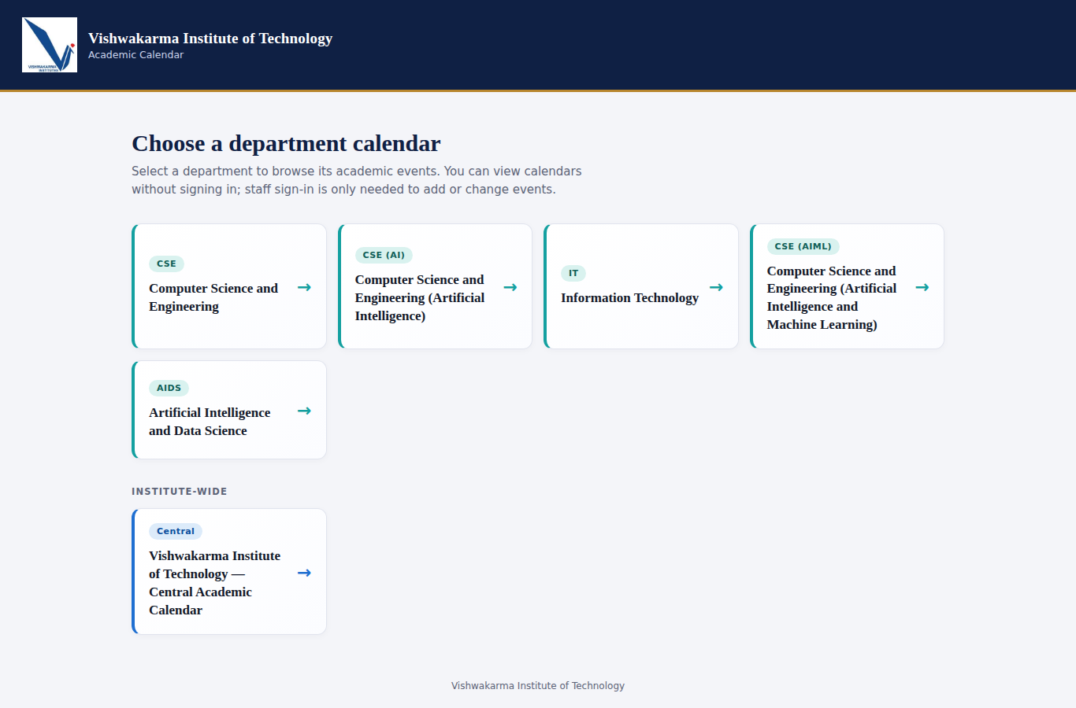
Figure 12.1: Department selection screen
After logging in as the department administrator (Figure 12.2), the toolbar shows the signed-in role, the Import Events button, the Edit / Delete buttons on each event and the poster and sharing tools. Department events are drawn in teal; the details panel shows the guest and the derived "Every Saturday" schedule for Future Ready Saturday.
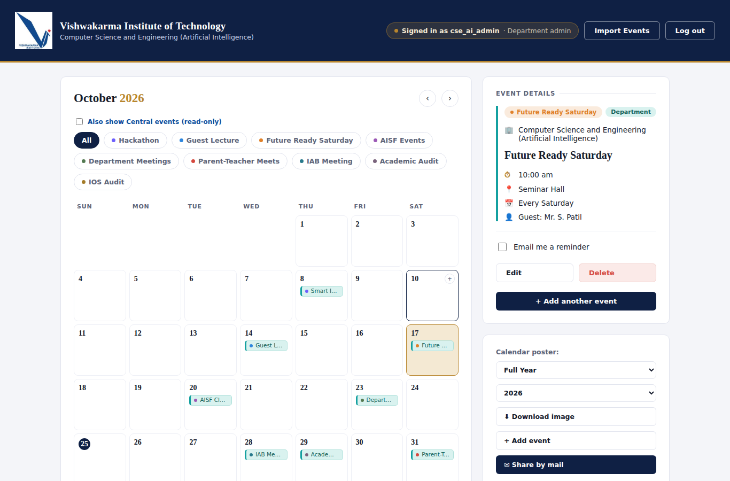
Figure 12.2: Calendar as seen by the department administrator
Figure 12.3 shows the import preview. The target calendar is stated at the top, followed by totals of detected, valid and invalid rows and possible duplicates. Categories found in the PDF (Exam, Fest, Seminar, Holiday, Workshop) that do not exist in this department must be created or mapped before confirmation, and every row can be edited or unchecked.
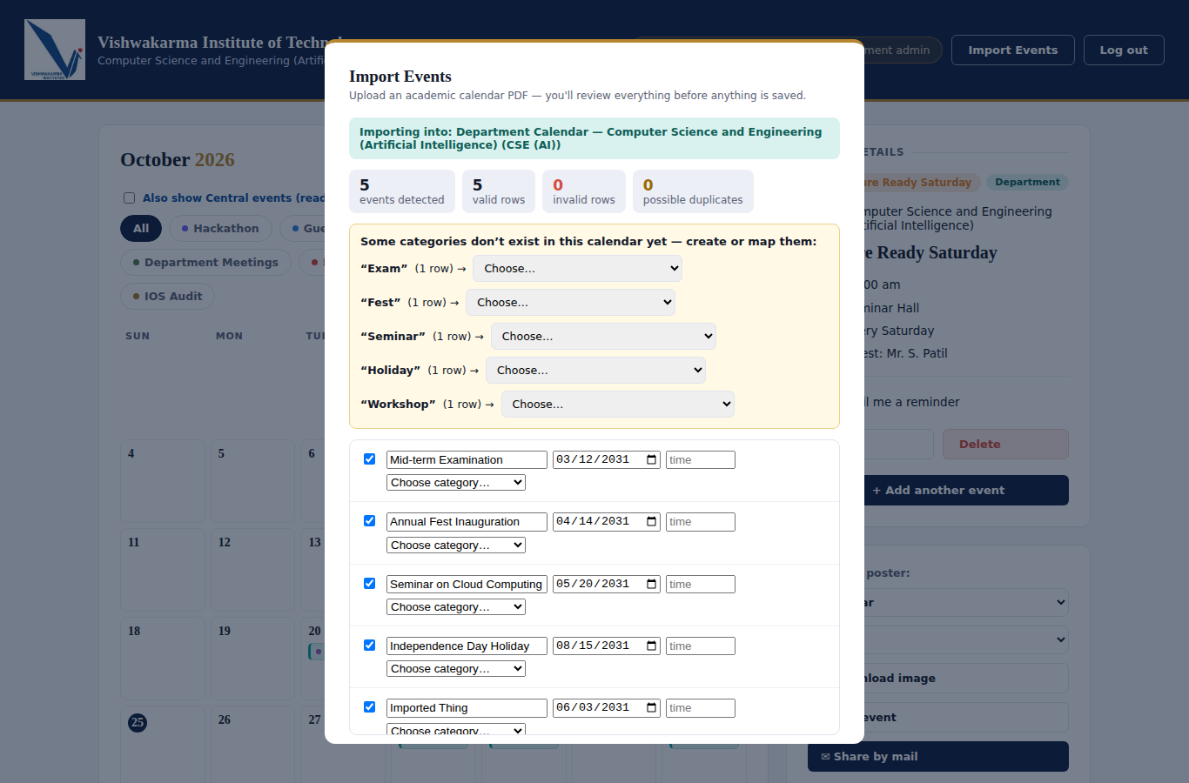
Figure 12.3: Import preview with category mapping and row editing
Figure 12.4 shows the Excel export for October 2026 with Central events included. It is a real spreadsheet (not an image) with a Sunday-Saturday grid, several events per date, blue cells for Central events and teal cells for Department events.

Figure 12.4: Monthly Excel calendar export (Central events in blue, Department events in teal)

12.2 System Performance
Response times were measured with 30 consecutive HTTP requests to the running server on the same machine (so they exclude network delay), with about twenty events stored. Table 12.1 gives the results; they are indicative and will vary with hardware and data volume.
Table 12.1: Measured response times (30 requests each, local server)
Request | Average (ms) | 95th percentile (ms) | Maximum (ms)
GET /d/cse-ai?year=2026&month=10 (full calendar page) | 10.6 | 20.1 | 45.3
GET /api/events?calendar=cse-ai (JSON) | 3.6 | 4.8 | 31.7
GET /api/categories?calendar=cse-ai (JSON) | 3.4 | 4.7 | 31.4

All three requests complete in a few milliseconds on average, far below the one-second non-functional target. The 108-check acceptance suite also runs end-to-end (including Excel generation and PDF parsing) in well under a minute.

12.3 Comparison with Objectives
Table 12.2: Comparison of results with the objectives
Sr. No. | Objective | Result
1 | Model real-world entities as classes and objects | Achieved: Event, Reminder, PdfEventExtractor plus repository and service objects (Chapters 7, 8, 10).
2 | Apply encapsulation, abstraction and polymorphism | Achieved: data hiding with userJSON(), service/repository abstraction, toJSON() and dbFor() polymorphism (Chapter 8). Inheritance is limited to error specialisation and the role hierarchy.
3 | Automate the manual process | Achieved: central web calendar, PDF import, Excel/poster export and e-mail sharing (Chapter 12).
4 | Enforce role-based security on the server | Achieved: 108 acceptance checks including cross-department, anonymous, XSS and brute-force cases all pass (Chapter 11).
5 | Reusable and maintainable code | Achieved: layered structure, data-driven departments/categories, idempotent migration. A monolithic server.js of 1,810 lines is a remaining maintainability concern (Chapter 13).
6 | Verify the system | Achieved: 108 acceptance checks plus 19 unit checks, all passing.

CHAPTER 13

ADVANTAGES AND LIMITATIONS

13.1 Advantages
- Single source of truth for six calendars with consistent colour coding and filters.
- Strong server-side security: role-based access, scrypt hashing, session regeneration, login throttling, bound SQL parameters and HTML escaping, verified by automated tests.
- Modularity and reusability: repositories, services and helper modules are independent; buildEvent() is reused by create, edit and import; departments and categories are data, not code.
- Safe evolution: the database migration is idempotent and never drops data, and the previous single-department installation upgrades in place.
- Productivity features: PDF import with preview, calendar-style Excel export, poster download, e-mail sharing and reminders.
- Testability: the acceptance suite verifies behaviour through HTTP, so internals can be refactored without breaking the tests.

13.2 Limitations
- Sessions are stored in memory, so users are logged out when the server restarts and several server instances would need a shared session store.
- Recurring categories are labels: "Every Saturday" and "Every Friday" mark one dated event; no repeated events are generated.
- Text-based PDFs only: scanned PDFs cannot be read, and the date-based extractor is heuristic, so the preview must always be reviewed.
- Event time is free text (for example "10:00 am"); sorting handles common formats but the value is not strictly validated.
- Limited use of class inheritance: the code favours composition, so some OOP concepts (abstract classes, interfaces, deep hierarchies) are only emulated; most logic lives in a single large server.js file.
- Unit tests were added for the helper functions only; the services are covered by the end-to-end suite rather than by isolated unit tests with mocks.
CHAPTER 14

FUTURE SCOPE

- Refactor to true class hierarchies: introduce class HttpError extends Error and class ValidationError extends HttpError, an abstract Repository base class with concrete EventRepository, CategoryRepository and so on, and split server.js into one file per class or layer. This would make inheritance and abstract classes explicit and improve maintainability.
- TypeScript migration to obtain real access modifiers (private, protected), interfaces and compile-time type checking.
- Generate recurring events automatically from the "Every Saturday / Every Friday" rules, with exceptions for holidays.
- Persistent session store (for example in the database or Redis) and HTTPS-only cookies in production.
- Scheduled e-mail and push notifications that actually send reminders at the chosen time.
- User-management screen for super administrators and an audit log of who changed which event.
CHAPTER 15

CONCLUSION

15.1 Summary of Work Done
A multi-department academic calendar system was designed, implemented and tested for Vishwakarma Institute of Technology. The application serves five department calendars and one Central calendar from a single code base and database. It offers role-based administration, category management with custom categories, PDF import with preview and atomic save, Excel and poster export, e-mail sharing and reminders. The design follows a layered object-oriented architecture with domain classes, repositories and services, and it was verified by 108 automated end-to-end checks and 19 unit checks, all of which pass.

15.2 Learning Outcomes Related to OOP
- Identified real-world entities and modelled them as classes with state and behaviour (Event, Reminder, PdfEventExtractor) and documented the design with UML use case, class, object, sequence, activity and state diagrams.
- Applied encapsulation (data hiding, module scope), abstraction (service and repository contracts) and polymorphism (toJSON(), interchangeable query functions) in a working system.
- Understood how OOP concepts translate to JavaScript, where overloading is emulated with default parameters, interfaces are replaced by documented contracts, and inheritance is used sparingly in favour of composition.
- Applied SOLID principles and patterns (MVC, Repository, Service Layer, Singleton, Factory, Chain of Responsibility, Unit of Work) to real requirements such as security and atomic imports.
- Practised exception handling, transactions, collections, file handling and database access, and learned to verify behaviour with unit and end-to-end tests.
CHAPTER 16

REFERENCES

[1] E. Gamma, R. Helm, R. Johnson and J. Vlissides, Design Patterns: Elements of Reusable Object-Oriented Software, Addison-Wesley, 1994.
[2] R. C. Martin, Agile Software Development: Principles, Patterns, and Practices, Prentice Hall, 2003.
[3] M. Fowler, Patterns of Enterprise Application Architecture, Addison-Wesley, 2002.
[4] G. Booch, J. Rumbaugh and I. Jacobson, The Unified Modeling Language User Guide, 2nd ed., Addison-Wesley, 2005.
[5] B. Meyer, Object-Oriented Software Construction, 2nd ed., Prentice Hall, 1997.
[6] I. Sommerville, Software Engineering, 10th ed., Pearson, 2015.
[7] OpenJS Foundation, "Node.js Documentation," https://nodejs.org/docs (accessed: [dd Month yyyy]).
[8] StrongLoop / IBM, "Express - Node.js web application framework," https://expressjs.com (accessed: [dd Month yyyy]).
[9] Mozilla, "JavaScript classes," MDN Web Docs, https://developer.mozilla.org/en-US/docs/Web/JavaScript/Reference/Classes (accessed: [dd Month yyyy]).
[10] Oracle Corporation, "MySQL Reference Manual," https://dev.mysql.com/doc/ (accessed: [dd Month yyyy]).
[11] ExcelJS contributors, "ExcelJS: read, manipulate and write spreadsheet data," https://github.com/exceljs/exceljs (accessed: [dd Month yyyy]).
[12] Mozilla, "PDF.js," https://mozilla.github.io/pdf.js/ (accessed: [dd Month yyyy]).
[13] OWASP Foundation, "OWASP Top Ten," https://owasp.org/www-project-top-ten/ (accessed: [dd Month yyyy]).
CHAPTER 17

APPENDIX

The complete source code (server/, scripts/, client/, database.sql) and the unit-check script unit-checks.js are submitted with this report in the project folder. A short user manual follows.

17.1 User Manual

17.1.1 For administrators
- Click "Staff log in" and sign in with the account of your own calendar.
- Add an event: click "+ Add event", choose the category (guest, agenda or schedule fields appear when needed), fill in title and date and click "Save event". Use Edit or Delete on an event to change it.
- Custom category: in the Add event form click "+ Add Custom Category", type a name and save; use Rename or Deactivate to manage it.
- Import: click "Import Events", choose Central or Department, select a text-based PDF, review the preview, map or create categories and confirm.
- Excel export: choose Monthly or Full-Year, month and year, and click "Download Excel".
- Poster and e-mail: download the calendar poster image or use "Share by mail" to send it to saved contacts.

